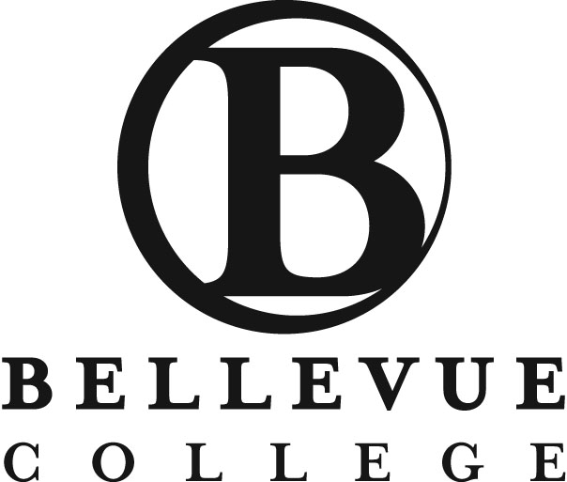

Student Programs S&A-Funded Travel
PERSONAL INFORMATION (Please print)
Name: Student ID#:
Email: Phone:

Emergency Contact: Phone

Do you have health insurance? (Please attach copy of insurance) Yes No
Allergies/ medication: Yes No
(If “yes” please list)
Dietary restrictions: Yes No
(If “yes” please specify)
What, if any, accommodations will you need for this trip?

Are you registered for classes at BC this quarter (if during break, past or future quarter)? Yes No
Are you 18 years of age as of today? Yes No
TRAVEL RULES & EXPECTIONS
While traveling on a Bellevue College (BC) sponsored trip, students are seen as representatives of the college and their conduct during the course of travel is of utmost importance. As a Traveler, you agree to the BC Student Conduct Code (WAC132H-125) for which the travel/conference entails, and to conform to all applicable rules, regulations, and policies of Bellevue College.

- There will be ABSOLUTELY NO ALCOHOL and / or DRUGS ALLOWED. You will be sent home immediately, at your own expense, if this rule is violated. Students will be referred to Student Conduct for disciplinary action.
- Attendance of all planned group activities and events associated with this travel is mandatory.
- The advisor for the travel will decide:
“Curfew” defined as follows: all students shall be in their own bed with music/TV turned down to a minimum
“Free time” (includes Sight-seeing with family/friends) if any, travel in pairs; this does not excuse you from
any travel related events or missing curfew.
- All incidental hotel charges and/or damage to rooms shall be paid by the responsible student(s) (all students are assigned to a room). Students are also responsible for any other damages during travel.
- When you cancel (or no-show) from going on the trip, Student Programs may incurs charges for air, hotel, registration, and other charges. Students may be responsible for paying those charges.
- Students have the right to a learning environment that is free from unlawful discrimination, inappropriate and disrespectful conduct, and any and all harassment, including sexual harassment. Students should contact the trip advisor with concerns while traveling and/or may report concerns to www.bellevuecollege.edu/reportconcerns/

Student Signature_______________________________________________ Date______________________
If the student is under age 18 (or if the student is 18 or older and has a legal guardian,) both the student and the parent or guardian must sign. In signing the parent or guardian acknowledges these travel rules
Parent or Guardian: Name: | Phone (include area code)
Parent or Guardian Signature: | Date
Street Address: | City, State, Zip Country

